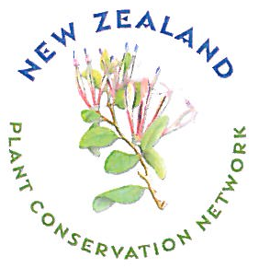
NEW ZEALAND PLANT CONSERVATION NETWORK

PLANT CONSERVATION AWARDS: 2012

The New Zealand Plant Conservation Network is now accepting nominations for the 2012 awards. The purpose of these awards is to acknowledge outstanding contributions to native plant conservation.

The award categories are:

􀀀 Individual involved in plant conservation
􀀀 Plant nursery involved in plant conservation
􀀀 School plant conservation project
􀀀 Community plant conservation project
􀀀 Local authority protecting native plant life
􀀀 Young Plant Conservationist of the Year (under 18 years at 30 June 2012)

More information about the awards scheme and additional nomination forms are available on the Network website - www.nzpcn.org.nz. You can make multiple nominations under different categories. Anyone is eligible to make nominations, not just Network members. The awards will be presented after the Network Annual General Meeting to be held on Thursday 29 November 2012 in Christchurch.. See the Network newsletter or website for more information.

NOMINATION FORM

Category (please circle):
Individual Plant Nursery School
Community Local Authority Young Plant Conservationist

Name of nominee:
Contact details for person, school, nursery, community group or local authority:
Address:

Phone: Email:
REASONS FOR NOMINATION:
(Please add more details on separate pages if required.)

Your Name:

Relationship to Nominee:

Your contact details:

Address

Phone Email:

Please send your nomination form by Tuesday 22 October 2012 to:
New Zealand Plant Conservation Network
P.O. Box 16-102
Wellington, New Zealand
Email: sarah@wildlands.co.nz
www.nzpcn.org.nz

